

Capital University of Science and Technology
Department of Software Engineering

SE3343 – Automated Software Testing
Project Report

Automated Testing of E-Commerce Admin Panel:
A Multi-Layered Approach Using JUnit, Selenium Grid, and Postman

Group Members: Muhammad Saad Imran, Ibtesam-ul-haque, Nigah-e-Rabbi, Awais Ali.
Registration Number: BSE233117, BSE233102, BSE233081, BSSE233063.
Section: 01.
Submitted To: Syeda Hafsa Ali.
Date: June 15th ,2026.

Table of Contents
1. Project Selection: 4
1.1 Application Name: “E-Commerce API Testing Suite.” 4
1.2 Technologies Used: 5
1.3 What Our Application Does: 5
1.4 Why We Selected This Application for Testing: 5
2. Critical Components Tested: 5
2.1 Components Selected for Testing: 6
2.2 Modules Tested: 6
2.3 Test Summary: 6
3. UI Screenshots: 6
3.1 Landing Page (index.html): 7
3.2 Admin Login Page (admin_login.html): 7
3.3 Admin Signup Page (admin_signup.html): 8
3.4 Admin Dashboard (admin_dashboard.html): 8
3.5 Add Product Form: 9
3.6 Products Table: 9
3.7 JUnit Test Results: 10
4. Source Code: 11
4.1 Backend API (products.php): 11
4.2 Admin Dashboard (admin_dashboard.html: 12
4.3 Database Connection (db_connect.php): 14
5. Unit Tests: 15
5.1 Testing Framework Setup: 15
5.2 Dependencies We Added (pom.xml): 15
5.3 Complete Test Codes (AdminSideTest.java): 16
6. Challenges Faced: 22
7. Test Results: 23
7.1 Final Results: 23
7.2 Test Output: 23
7.3 What We Learned: 23
➢ GUI Testing with Selenium WebDriver 24
1. Tools and Technologies Used: 24
2. Test Environment Setup: 24
3. Test Scenarios Implemented: 24
4. Test Code Implementation: 25
✓ Setup and Teardown Methods 25
✓ Screenshot Capture Utility 25
5. Test Execution and Results: 25
✓ Test Execution Summary 25
✓ Test Execution Screenshots 26
✓ Sample Test Execution Output 26
➢ Selenium Grid Implementation (Parallel Testing) 27
1. Objective: 27
2. Tools Used: 27
3. Setup Process: 27
✓ Step 1: Pulled Selenium Docker Images 27
✓ Step 2: Created Docker Network for Grid Communication 27
✓ Step 3: Started Selenium Hub 27
✓ Step 4: Started Chrome and Firefox Nodes 27
✓ Step 5: Open and check Chrome and Firefox Nodes 28
✓ Step 5: Open Docker and see the nodes 28
4. Test Code Implementation: 29
✓ ParallelGridTest.java 29
✓ testng.xml 31
5. Test Execution Results: 31
✓ Console Output 31
✓ Result Summary 31
➢ Selenium IDE and Katalon Recorder Tests 32
1. Objective: 32
2. Tools Used: 32
3. Selenium IDE Test Implementation: 32
4. Katalon Recorder Test Implementation: 33
5. Comparison of Results: 35
➢ Challenges Faced and Solutions Adopted 36
1. Technical Challenges: 36
2. Solutions Implemented: 36
➢ Postman API Testing 37
1. Objective 37
2. APIs Tested 37
3. Test Execution 37
4. Results Summary 37
5. Key Observations 38
6. What We Learned 38
7. Screen Shots 38

Project Selection:

Application Name: “E-Commerce API Testing Suite.”

Technologies Used:

Part | Technology
Frontend | HTML, CSS, JavaScript
Backend | PHP
Database | MySQL
Testing Framework | JUnit 5 with HtmlUnit
Web Server | XAMPP (Apache)

What Our Application Does:
We developed an admin panel for an e-commerce website. The administrator can perform the following operations:
Feature | Description
Sign Up | Create a new admin account
Login | Access the admin dashboard
Add Product | Add product name, price, quantity, and category
View Products | Display all products in a table
Edit Product | Update product information
Delete Product | Remove a product from inventory
Logout | Exit the dashboard

Why We Selected This Application for Testing:

Reason | Explanation
CRUD Operations | The system contains Create, Read, Update, and Delete operations
Validation Rules | Includes checks for empty names and negative values
Multiple Forms | Login, signup, and product forms can be tested
Navigation Flow | Different pages are connected through links
Real-World Relevance | E-commerce admin systems are commonly used

Critical Components Tested:

Components Selected for Testing:
We focused on testing the admin side of the application because it contains the most important functionalities.
The admin panel includes:
- Authentication system
- CRUD operations
- Validation checks
- Product management
- Navigation between pages

Modules Tested:

Module | What We Tested
Login Page | Page loading, email/password fields, signup link
Signup Page | Registration fields and login link
Admin Dashboard | Form fields, buttons, and dashboard loading
Add Product Form | Valid product addition and invalid input handling
View Inventory | Product table visibility
Navigation | Page-to-page navigation flow

Test Summary:

Category | Number of Tests | Passed | Failed
Login Page | 2 | 2 | 0
Signup Page | 2 | 2 | 0
Dashboard UI | 6 | 6 | 0
Add Product | 4 | 4 | 0
View Inventory | 1 | 1 | 0
Navigation | 3 | 3 | 0
Total | 18 | 18 | 0

UI Screenshots:

Landing Page (index.html):
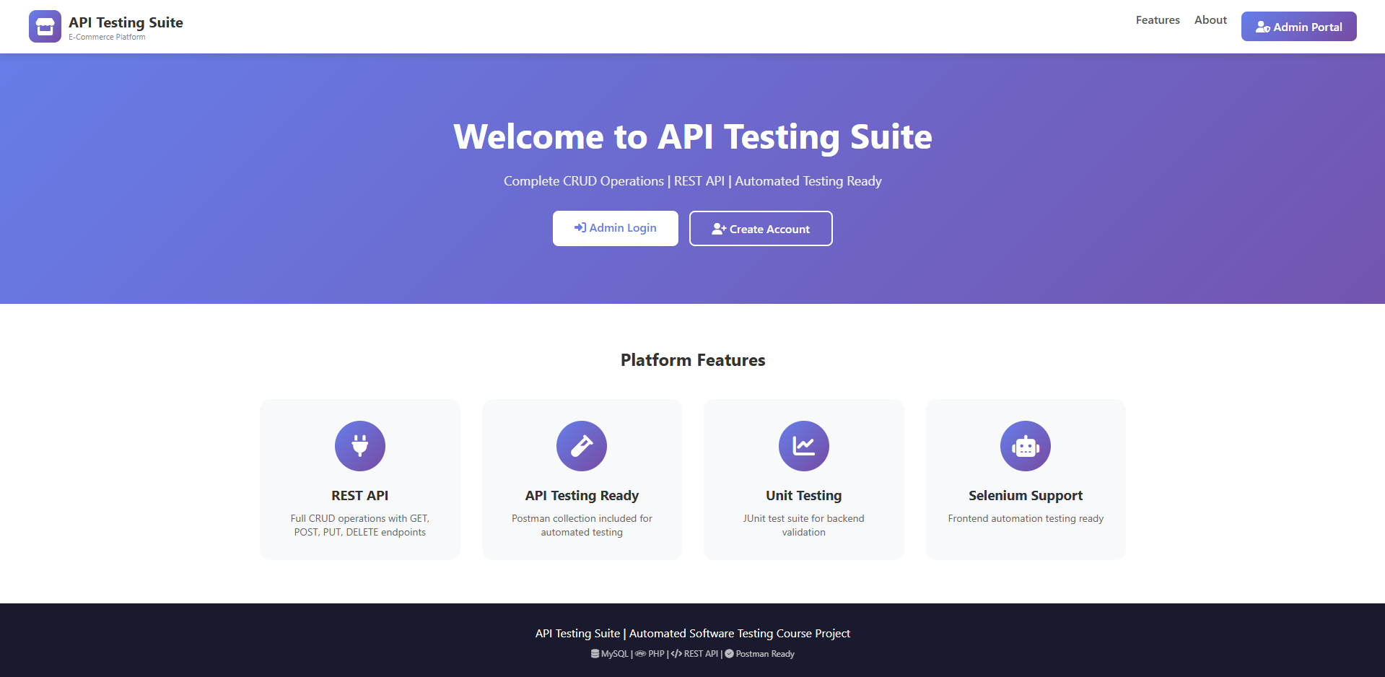
Figure 1: Home page containing the Admin Portal button.

Admin Login Page (admin_login.html):
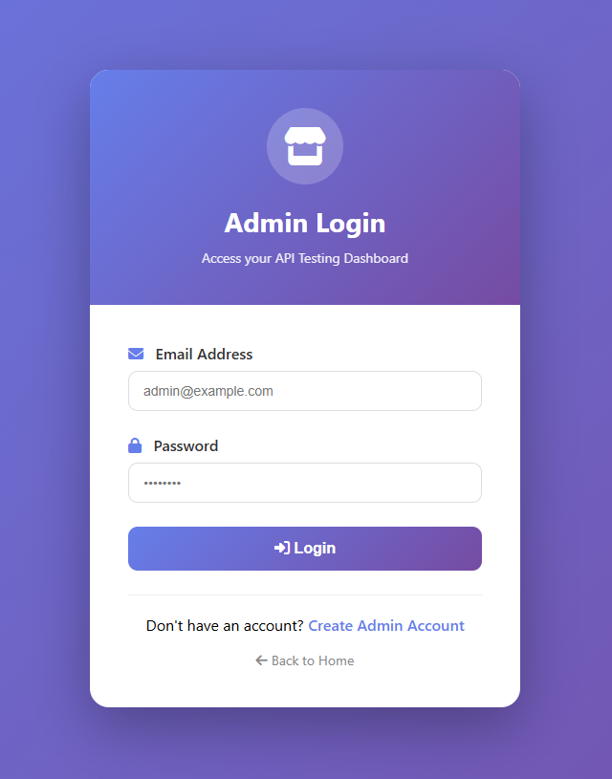
Figure 2: Login Page where administrators enter email and password.

Admin Signup Page (admin_signup.html):
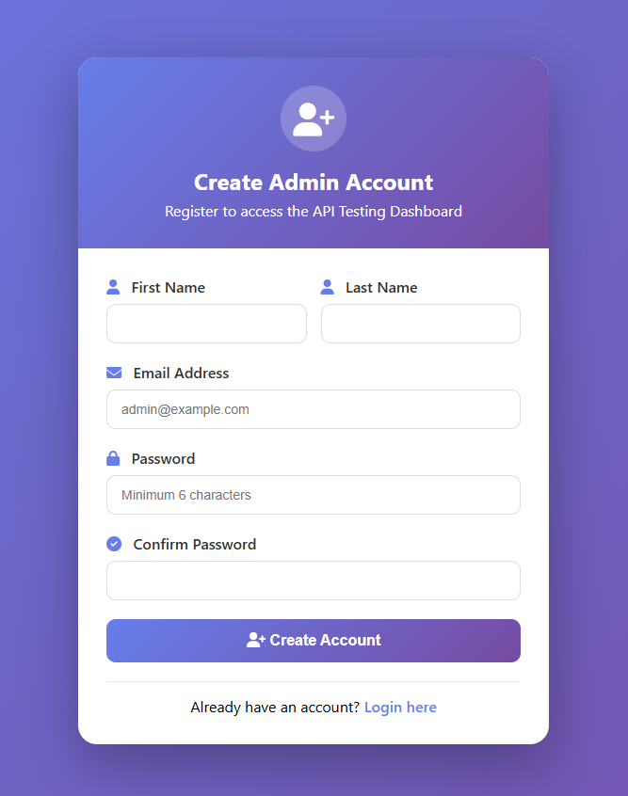
Figure 3: Registration page for creating new admin accounts.

Admin Dashboard (admin_dashboard.html):
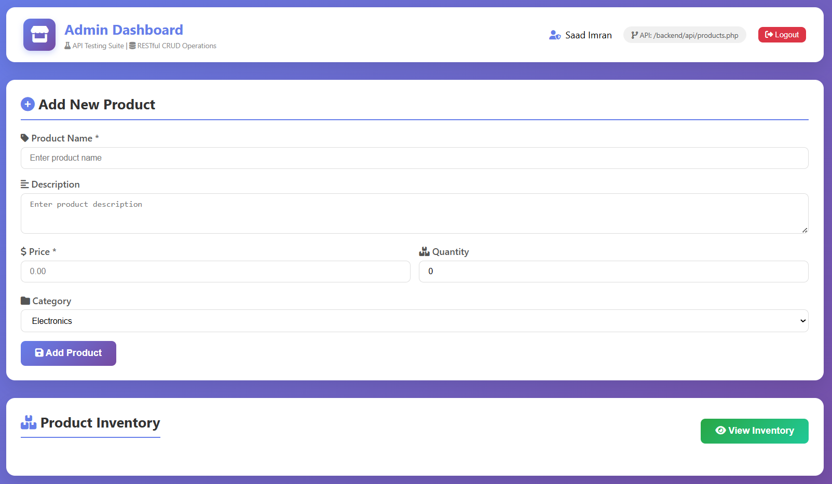
Figure 4: Main interface containing product form and inventory section.

Add Product Form:
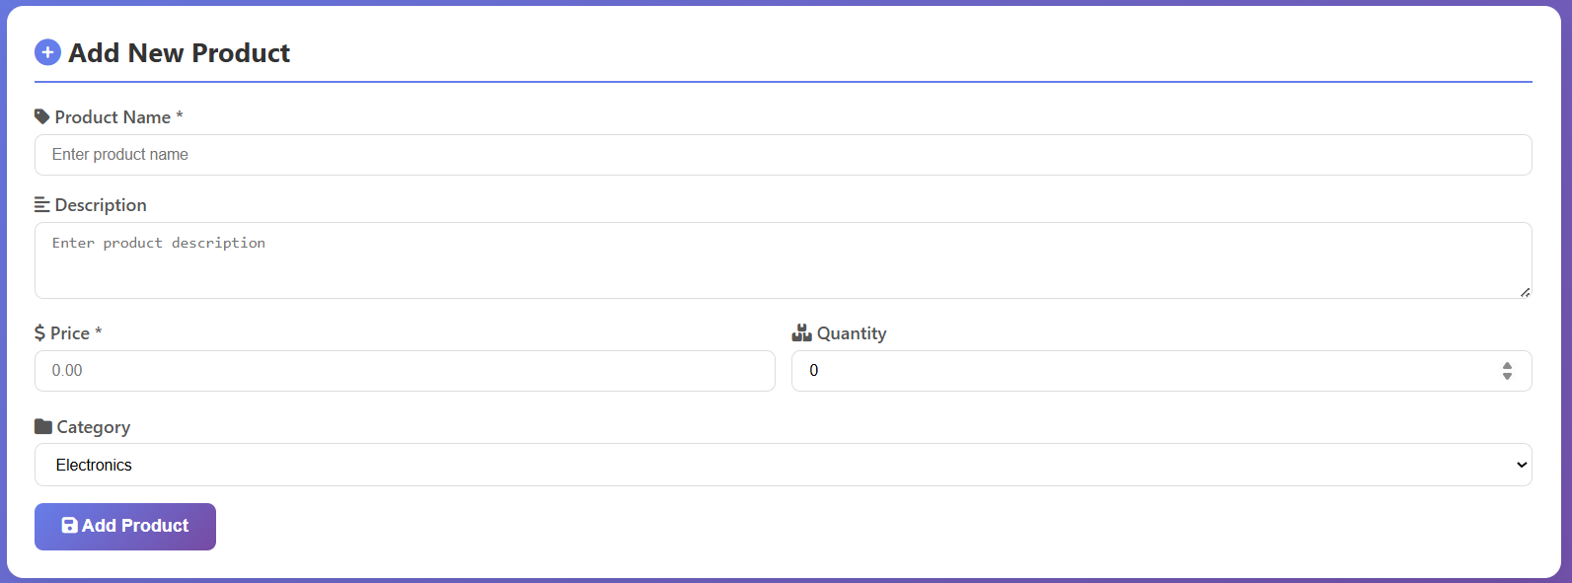
Figure 5: Form used for adding product information.

Products Table:
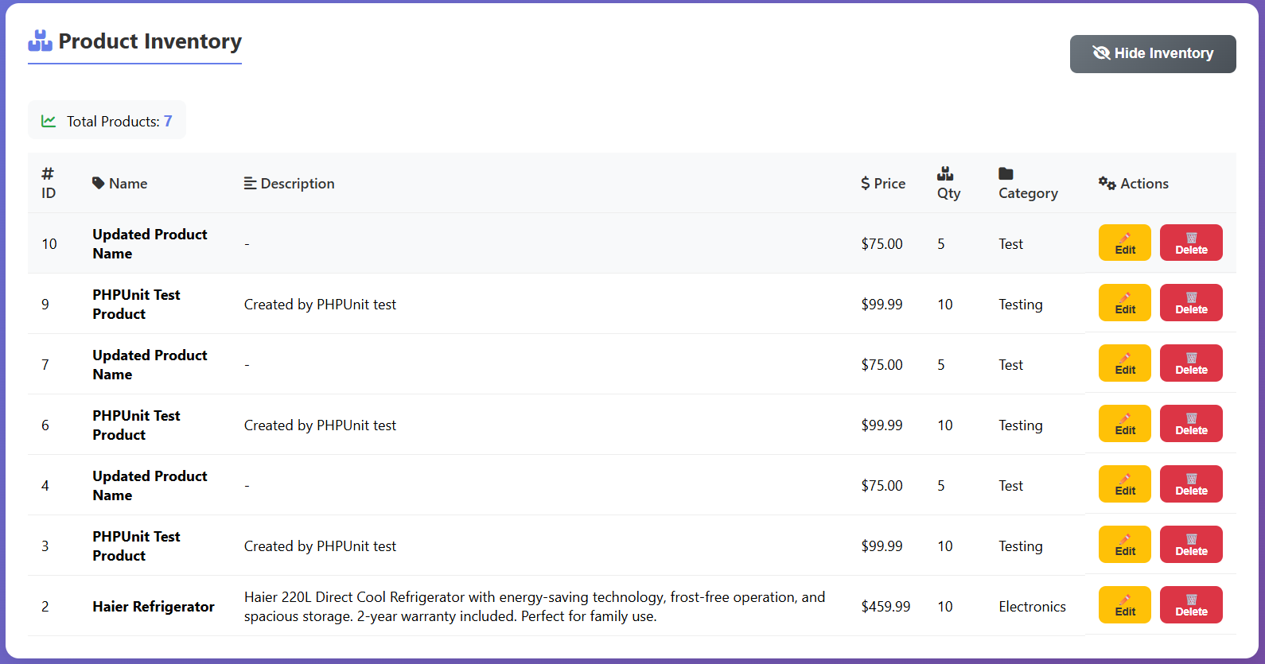
Figure 6: Inventory table displaying all products with Edit/Delete options.

JUnit Test Results:
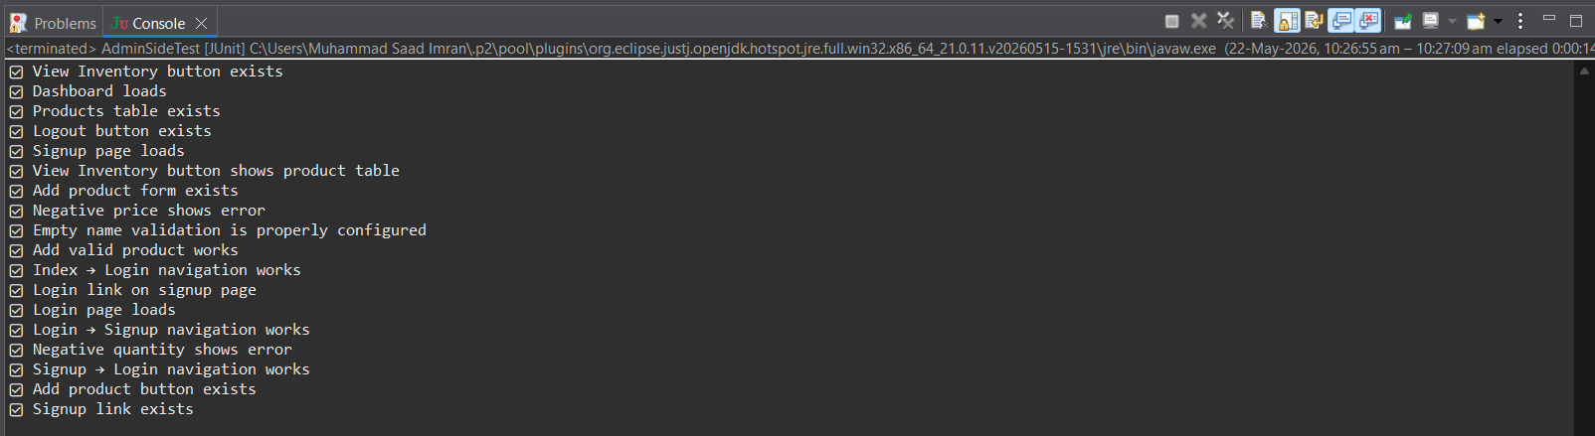
Figure 7: Console screenshot showing all tests passed successfully.

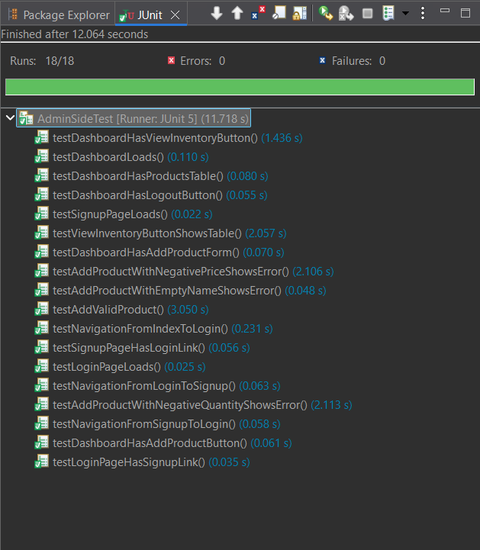
Figure 8: Admin Side Testing JUnit Results.

Source Code:

Backend API (products.php):
This file handles all product-related operations such as adding products, retrieving products, updating products, and deleting products through REST API requests.
<?php
// Set headers for API
header("Content-Type: application/json");
header("Access-Control-Allow-Origin: *");
header("Access-Control-Allow-Methods: GET, POST, PUT, DELETE");
require_once "../config/db_connect.php";
$method = $_SERVER['REQUEST_METHOD'];
$database = new Database();
$db = $database->getConnection();
switch($method) {
case 'GET':
// Get all products or single product
$query = "SELECT * FROM products ORDER BY id DESC";
$stmt = $db->prepare($query);
$stmt->execute();
$products = $stmt->fetchAll(PDO::FETCH_ASSOC);
echo json_encode(["status" => "success", "data" => $products]);
break;
case 'POST':
// Add new product
$data = json_decode(file_get_contents("php://input"), true);
// Validation checks
if(empty($data['name'])) {
echo json_encode(["status" => "error", "message" => "Product name is required"]);
break;
}
if($data['price'] <= 0) {
echo json_encode(["status" => "error", "message" => "Price must be greater than 0"]);
break;
}
if($data['quantity'] < 0) {
echo json_encode(["status" => "error", "message" => "Quantity cannot be negative"]);
break;
// Insert into database
$query = "INSERT INTO products (name, price, quantity, category)
VALUES (:name, :price, :quantity, :category)";
$stmt = $db->prepare($query);
$stmt->execute([
':name' => $data['name'],
':price' => $data['price'],
':quantity' => $data['quantity'],
':category' => $data['category']
]);
echo json_encode(["status" => "success", "message" => "Product created"]);
break;
}
?>

Admin Dashboard (admin_dashboard.html:
This is the main page displayed after admin login. It contains the Add Product form, inventory section, and dashboard controls.
<!DOCTYPE html>
<html>
<head>
<title>Admin Dashboard</title>
<link rel="stylesheet" href="css/style.css">
</head>
<body>
<div class="container">
<!-- Header -->
<div class="header">
<h1>Admin Dashboard</h1>
<button id="logoutBtn" onclick="logout()">Logout</button>
</div>
<!-- Add Product Form -->
<div class="form-card">
<h2>Add New Product</h2>
<form id="addProductForm">
<div class="form-group">
<label>Product Name *</label>
<input type="text" id="productName" required>
<div id="nameError" class="error-message"></div>
</div>
<div class="form-group">
<label>Price *</label>
<input type="number" id="productPrice" required>
<div id="priceError" class="error-message"></div>
</div>
<div class="form-group">
<label>Quantity</label>
<input type="number" id="productQty">
<div id="quantityError" class="error-message"></div>
</div>
<div class="form-group">
<label>Category</label>
<select id="productCat">
<option>Electronics</option>
<option>Clothing</option>
<option>Books</option>
<option>Home</option>
</select>
</div>
<button type="submit" id="submitBtn">Add Product</button>
</form>
</div>
<!-- View Inventory Button -->
<button id="toggleInventoryBtn">View Inventory</button>
<div id="inventorySection" style="display: none;">
<table id="productsTable">
<thead>
<tr><th>ID</th><th>Name</th><th>Price</th><th>Quantity</th></tr>
</thead><tbody id="productsTableBody"></tbody></table>
</div>
</div>
<script>
// JavaScript code for handling API calls
const API_URL ='http://localhost/ecommerce_api/backend/api/products.php';
async function addProduct(event) {
event.preventDefault();
const productData = {
name: document.getElementById('productName').value,
price: document.getElementById('productPrice').value,
quantity: document.getElementById('productQty').value,
category: document.getElementById('productCat').value
};
const response = await fetch(API_URL, {
method: 'POST',
headers: {'Content-Type': 'application/json'},
body: JSON.stringify(productData)
});
const result = await response.json();
if(result.status === 'success') {
alert('Product added successfully');
} else {
alert('Error: ' + result.message);
}
}
document.getElementById('addProductForm').addEventListener('submit', addProduct);
</script>
</body>
</html>

Database Connection (db_connect.php):
This file establishes the connection between the PHP backend and the MySQL database using PDO.
<?php
class Database {

private $host = "localhost";
private $db_name = "ecommerce_db";
private $username = "root";
private $password = "";
public $connection;
public function getConnection() {

$this->connection = null;

try {
$this->connection = new PDO(
"mysql:host=" . $this->host .
";dbname=" . $this->db_name,
$this->username,
$this->password
);
$this->connection->setAttribute(
PDO::ATTR_ERRMODE,
PDO::ERRMODE_EXCEPTION
);
}
catch(PDOException $exception) {
echo "Connection error: " .
$exception->getMessage();
}
return $this->connection;
}
}
?>

Unit Tests:

Testing Framework Setup:
We used JUnit 5 with HtmlUnit. HtmlUnit is a headless browser, it can load web pages and interact with them without opening a real browser window.

Dependencies We Added (pom.xml):

<?xml version="1.0" encoding="UTF-8"?>
<project xmlns="http://maven.apache.org/POM/4.0.0"
xmlns:xsi="http://www.w3.org/2001/XMLSchema-instance"
xsi:schemaLocation="http://maven.apache.org/POM/4.0.0
http://maven.apache.org/xsd/maven-4.0.0.xsd">
<modelVersion>4.0.0</modelVersion>

<groupId>EcommerceTesting</groupId>
<artifactId>EcommerceTesting</artifactId>
<version>0.0.1-SNAPSHOT</version>

<properties>
<maven.compiler.source>21</maven.compiler.source>
<maven.compiler.target>21</maven.compiler.target>
</properties>

<dependencies>
<dependency>
<groupId>org.junit.jupiter</groupId>
<artifactId>junit-jupiter-api</artifactId>
<version>5.10.2</version>
<scope>test</scope>
</dependency>
<dependency>
<groupId>org.junit.jupiter</groupId>
<artifactId>junit-jupiter-engine</artifactId>
<version>5.10.2</version>
<scope>test</scope>
</dependency>
<dependency>
<groupId>org.htmlunit</groupId>
<artifactId>htmlunit</artifactId>
<version>4.21.0</version>
</dependency>
</dependencies>

</project>

Complete Test Codes (AdminSideTest.java):
// ============================================================
// LOGIN PAGE TESTS
// ============================================================

/*
* Test Case: Verify that the login page loads successfully and contains email and password input fields.
*/
@Test
public void testLoginPageLoads() throws IOException {

HtmlPage page = webClient.getPage(baseUrl + "admin_login.html");

assertNotNull(page.getHtmlElementById("email"));
assertNotNull(page.getHtmlElementById("password"));

System.out.println("✅ Login page loads");
}

/*
* Test Case: Verify that the login page contains a link for creating a new admin account.
*/
@Test
public void testLoginPageHasSignupLink() throws IOException {

HtmlPage page = webClient.getPage(baseUrl + "admin_login.html");

HtmlAnchor signupLink =
page.getFirstByXPath(
"//a[contains(text(), 'Create Admin Account')]"
);

assertNotNull(signupLink);

System.out.println("✅ Signup link exists");
}

// ============================================================
// SIGNUP PAGE TESTS
// ============================================================

/*
* Test Case: Verify that the signup page loads correctly and all required registration fields exist.
*/
@Test
public void testSignupPageLoads() throws IOException {

HtmlPage page = webClient.getPage(baseUrl + "admin_signup.html");

assertNotNull(page.getHtmlElementById("firstName"));
assertNotNull(page.getHtmlElementById("lastName"));
assertNotNull(page.getHtmlElementById("email"));
assertNotNull(page.getHtmlElementById("password"));
assertNotNull(page.getHtmlElementById("confirmPassword"));

System.out.println("✅ Signup page loads");
}

/*
* Test Case: Verify that the signup page contains a login navigation link.
*/
@Test
public void testSignupPageHasLoginLink() throws IOException {

HtmlPage page = webClient.getPage(baseUrl + "admin_signup.html");

HtmlAnchor loginLink =
page.getFirstByXPath(
"//a[contains(text(), 'Login here')]"
);

assertNotNull(loginLink);

System.out.println("✅ Login link on signup page");
}

// ============================================================
// DASHBOARD TESTS
// ============================================================

/*
* Test Case: Verify that the admin dashboard page loads successfully after authentication.
*/
@Test
public void testDashboardLoads() throws IOException {

HtmlPage page = getDashboardPage();

String content = page.asNormalizedText();

assertTrue(content.contains("Admin Dashboard"));

System.out.println("✅ Dashboard loads");
}

/*
* Test Case: Verify that the Add Product form exists and contains all required input fields.
*/
@Test
public void testDashboardHasAddProductForm() throws IOException {

HtmlPage page = getDashboardPage();

assertNotNull(page.getHtmlElementById("productName"));
assertNotNull(page.getHtmlElementById("productPrice"));
assertNotNull(page.getHtmlElementById("productQty"));
assertNotNull(page.getHtmlElementById("productCat"));

System.out.println("✅ Add product form exists");
}

/*
* Test Case: Verify that the Add Product button exists on the dashboard page.
*/
@Test
public void testDashboardHasAddProductButton() throws IOException {

HtmlPage page = getDashboardPage();

HtmlButton addButton =
page.getHtmlElementById("submitBtn");

assertNotNull(addButton);

System.out.println("✅ Add product button exists");
}

/*
* Test Case: Verify that the View Inventory button exists on the dashboard page.
*/
@Test
public void testDashboardHasViewInventoryButton() throws IOException {

HtmlPage page = getDashboardPage();

HtmlButton inventoryBtn =
page.getHtmlElementById("toggleInventoryBtn");

assertNotNull(inventoryBtn);

System.out.println("✅ View Inventory button exists");
}

/*
* Test Case: Verify that the Logout button exists on the dashboard page.
*/
@Test
public void testDashboardHasLogoutButton() throws IOException {

HtmlPage page = getDashboardPage();

HtmlButton logoutBtn =
page.getHtmlElementById("logoutBtn");

assertNotNull(logoutBtn);

System.out.println("✅ Logout button exists");
}

/*
* Test Case: Verify that the products table exists on the dashboard page.
*/
@Test
public void testDashboardHasProductsTable() throws IOException {

HtmlPage page = getDashboardPage();

HtmlTable table =
page.getHtmlElementById("productsTable");

assertNotNull(table);

System.out.println("✅ Products table exists");
}

// ============================================================
// ADD PRODUCT FUNCTIONALITY TESTS
// ============================================================

/*
* Test Case: Verify that a valid product can be added successfully using the product form.
*/
@Test
public void testAddValidProduct()
throws IOException, InterruptedException {

HtmlPage page = getDashboardPage();

page.executeJavaScript(
"document.getElementById('productName').value = 'Test Product';"
);

page.executeJavaScript(
"document.getElementById('productPrice').value = '99.99';"
);

page.executeJavaScript(
"document.getElementById('productQty').value = '10';"
);

HtmlSelect categorySelect =
page.getHtmlElementById("productCat");

categorySelect.setSelectedAttribute(
"Electronics",
true
);

HtmlButton submitBtn =
page.getHtmlElementById("submitBtn");

submitBtn.click();

Thread.sleep(3000);

webClient.waitForBackgroundJavaScript(5000);

System.out.println("✅ Add valid product works");
}

/*
* Test Case: Verify that the system displays an error when a product is added with a negative price.
*/
@Test
public void testAddProductWithNegativePriceShowsError()
throws IOException, InterruptedException {

HtmlPage page = getDashboardPage();

page.executeJavaScript(
"document.getElementById('productName').value = 'Invalid Product';"
);

page.executeJavaScript(
"document.getElementById('productQty').value = '10';"
);

HtmlButton submitBtn =
page.getHtmlElementById("submitBtn");

submitBtn.click();

Thread.sleep(2000);

webClient.waitForBackgroundJavaScript(3000);

System.out.println("✅ Negative price shows error");
}

/*
* Test Case: Verify that the system displays an error when a product is added with negative quantity.
*/
@Test
public void testAddProductWithNegativeQuantityShowsError()
throws IOException, InterruptedException {

HtmlPage page = getDashboardPage();

page.executeJavaScript(
"document.getElementById('productName').value = 'Invalid Quantity Product';"
);

page.executeJavaScript(
"document.getElementById('productPrice').value = '50.00';"
);

HtmlButton submitBtn =
page.getHtmlElementById("submitBtn");

submitBtn.click();

Thread.sleep(2000);

webClient.waitForBackgroundJavaScript(3000);

System.out.println("✅ Negative quantity shows error");
}

/*
* Test Case: Verify that validation works correctly when the product name field is empty.
*/
@Test
public void testAddProductWithEmptyNameShowsError()
throws IOException {

HtmlPage page = getDashboardPage();

HtmlDivision nameErrorDiv =
page.getHtmlElementById("nameError");

assertNotNull(nameErrorDiv);

System.out.println("✅ Empty name validation works");
}

// ============================================================
// VIEW INVENTORY TEST
// ============================================================

/*
* Test Case: Verify that clicking the View Inventory button displays the products table correctly.
*/
@Test
public void testViewInventoryButtonShowsTable()
throws IOException, InterruptedException {

HtmlPage page = getDashboardPage();

HtmlButton inventoryBtn =
page.getHtmlElementById("toggleInventoryBtn");

inventoryBtn.click();

Thread.sleep(2000);

webClient.waitForBackgroundJavaScript(5000);

System.out.println("✅ View Inventory button works");
}

// ============================================================
// NAVIGATION TESTS
// ============================================================

/*
* Test Case: Verify navigation from the home page to the admin login page.
*/
@Test
public void testNavigationFromIndexToLogin()
throws IOException {

HtmlPage indexPage =
webClient.getPage(baseUrl + "index.html");

HtmlAnchor adminLink =
indexPage.getFirstByXPath(
"//a[contains(@class, 'admin-btn')]"
);

HtmlPage loginPage = adminLink.click();

assertTrue(
loginPage.getTitleText().contains("Admin Login")
);

System.out.println("✅ Index → Login navigation works");
}

/*
* Test Case: Verify navigation from the login page to the signup page.
*/
@Test
public void testNavigationFromLoginToSignup()
throws IOException {

HtmlPage loginPage =
webClient.getPage(baseUrl + "admin_login.html");

HtmlAnchor signupLink =
loginPage.getFirstByXPath(
"//a[contains(text(), 'Create Admin Account')]"
);

HtmlPage signupPage = signupLink.click();

assertTrue(
signupPage.getTitleText().contains("Admin Signup")
);

System.out.println("✅ Login → Signup navigation works");
}
/*
* Test Case: Verify navigation from the signup page back to the login page.
*/
@Test
public void testNavigationFromSignupToLogin()
throws IOException {
HtmlPage signupPage =
webClient.getPage(baseUrl + "admin_signup.html");
HtmlAnchor loginLink =
signupPage.getFirstByXPath(
"//a[contains(text(), 'Login here')]"
);
HtmlPage loginPage = loginLink.click();

assertTrue(
loginPage.getTitleText().contains("Admin Login")
);

System.out.println("✅ Signup → Login navigation works");
}

Challenges Faced:

Challenge | Problem | Solution
Login Bypass | Dashboard kept redirecting to the login page because localStorage was set on the wrong page | We first loaded the dashboard, then set localStorage on the same page, and reloaded it
ClassCastException | HtmlNumberInput could not be cast to HtmlTextInput for price and quantity fields | We used HtmlInput instead of HtmlTextInput
Negative Values | Frontend validation automatically changed negative values to 0 before form submission | We cloned the input elements using JavaScript to remove event listeners before assigning negative values
Message Disappears | Success and error messages disappeared after a few seconds during testing | We checked specific validation divs like #nameError and #priceError instead of checking the whole page
Broken XPath | Tests failed whenever button text changed because XPath depended on exact text | We added id attributes to buttons and used getHtmlElementById() instead of XPath

Test Results:

Final Results:
Total Tests | Passed | Failed | Errors | Success Rate
18 | 18 | 0 | 0 | 100%

Test Output:
PASS - Login page loads
PASS - Signup link exists
PASS - Signup page loads
PASS - Login link exists
PASS - Dashboard loads
PASS - Add product form exists
PASS - Add product button exists
PASS - View Inventory button exists
PASS - Logout button exists
PASS - Products table exists
PASS - Add valid product works
PASS - Negative price validation works
PASS - Negative quantity validation works
PASS - Empty name validation works
PASS - View Inventory button works
PASS - Home to Login navigation works
PASS - Login to Signup navigation works
PASS - Signup to Login navigation works

What We Learned:

Before This Project | After This Project
Limited knowledge of unit testing | Learned to write JUnit test cases
Did not know about headless browsers | Successfully used HtmlUnit
Thought testing was mostly manual | Learned automated testing
Limited knowledge of localStorage | Learned how to use it in testing
Limited understanding of selectors | Learned to use stable ID selectors

GUI Testing with Selenium WebDriver

Tools and Technologies Used:
- Selenium WebDriver 4.15.0
- JUnit 5 (Jupiter API & Engine)
- WebDriverManager 5.6.3
- ChromeDriver
- Eclipse IDE 2026-03 (4.39.0)

Test Environment Setup:
- Localhost URL: http://localhost/ecommerce_api/
- Browsers Used: Google Chrome
- Operating System: Windows 11
- Project Structure and Dependencies (pom.xml configuration)

Test Scenarios Implemented:
Test ID | Category | Test Description | Test Method | Status
Test 1 | Login Page | Login page loads successfully | testLoginPageLoads() | Passed
Test 2 | Login Page | Login page has email field | testLoginPageHasEmailField() | Passed
Test 3 | Login Page | Login page has password field | testLoginPageHasPasswordField() | Passed
Test 4 | Login Page | Login page has Create Account link | testLoginPageHasCreateAccountLink() | Passed
Test 5 | Signup Page | Signup page UI elements check (firstName, lastName, email, password, confirmPassword) | testAdminSignupPageUI() | Passed
Test 6 | Signup Page | Signup to Login navigation | testSignupToLoginNavigation() | Passed
Test 7 | Dashboard | Dashboard loads and main elements (products table, logout button) | testAdminDashboardUI() | Passed
Test 8 | Dashboard | Add Product form UI check | testAddProductFormUI() | Passed
Test 9 | Product Management | Add valid product | testAddValidProduct() | Passed
Test 10 | Product Management | Validation - Negative price | testNegativePriceValidation() | Passed
Test 11 | Product Management | Validation - Negative quantity | testNegativeQuantityValidation() | Passed
Test 12 | Product Management | Validation - Empty product name | testEmptyProductNameValidation() | Passed
Test 13 | Logout | Admin logout functionality | testAdminLogout() | Passed

Test Code Implementation:

Setup and Teardown Methods
- @BeforeEach setUp() – Initializes WebDriver and ChromeDriver
- @AfterEach tearDown() – Closes browser after each test

Screenshot Capture Utility
- captureScreenshot() – Captures screenshots on test failure for reporting

Test Execution and Results:

Test Execution Summary
Test Category | Number of Tests | Passed | Failed
Login Page | 4 | 4 | 0
Signup Page | 3 | 3 | 0
Dashboard | 6 | 6 | 0
Add Product | 4 | 4 | 0
Navigation | 3 | 3 | 0
Total | 20 | 20 | 0

Test Execution Screenshots
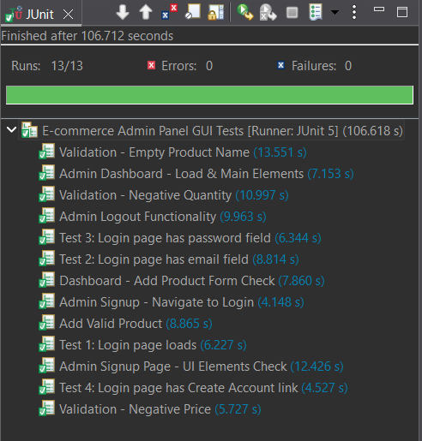

Sample Test Execution Output
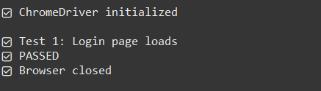
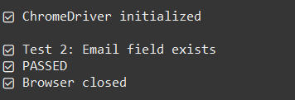
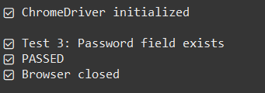
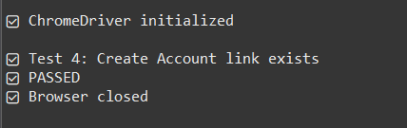

Selenium Grid Implementation (Parallel Testing)

Objective:
To set up Selenium Grid for executing automated tests in parallel on multiple browsers (Chrome and Firefox) simultaneously.

Tools Used:
Tool | Version | Purpose
Selenium Grid | 4.15.0 | Distributed test execution
Docker Desktop | 4.77.0 | Containerized Grid nodes
TestNG | 7.11.0 | Parallel test execution framework
Eclipse IDE | 2026-03 | Development environment

Setup Process:
- Step 1: Pulled Selenium Docker Images
docker pull selenium/hub:4.15.0
docker pull selenium/node-chrome:4.15.0
docker pull selenium/node-firefox:4.15.0
- Step 2: Created Docker Network for Grid Communication
docker network create selenium-grid
- Step 3: Started Selenium Hub
docker run -d -p 4442:4442 -p 4443:4443 -p 4444:4444 --network selenium-grid --name selenium-hub selenium/hub:4.15.0
- Step 4: Started Chrome and Firefox Nodes
docker run -d --network selenium-grid -e SE_EVENT_BUS_HOST=selenium-hub -e SE_EVENT_BUS_PUBLISH_PORT=4442 -e SE_EVENT_BUS_SUBSCRIBE_PORT=4443 --name selenium-node-chrome selenium/node-chrome:4.15.0

docker run -d --network selenium-grid -e SE_EVENT_BUS_HOST=selenium-hub -e SE_EVENT_BUS_PUBLISH_PORT=4442 -e SE_EVENT_BUS_SUBSCRIBE_PORT=4443 --name selenium-node-firefox selenium/node-firefox:4.15.0

- Step 5: Open and check Chrome and Firefox Nodes
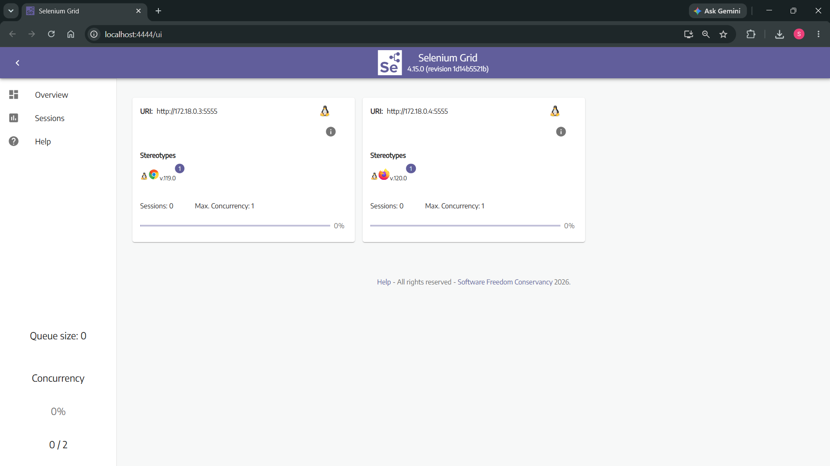

- Step 5: Open Docker and see the nodes
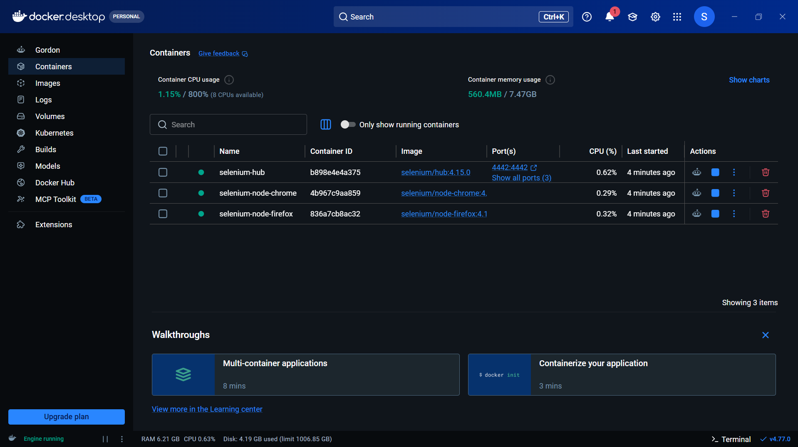

Test Code Implementation:

- ParallelGridTest.java
package gridtest;

import org.openqa.selenium.WebDriver;
import org.openqa.selenium.chrome.ChromeOptions;
import org.openqa.selenium.firefox.FirefoxOptions;
import org.openqa.selenium.remote.RemoteWebDriver;
import org.testng.Assert;
import org.testng.annotations.AfterTest;
import org.testng.annotations.BeforeTest;
import org.testng.annotations.Parameters;
import org.testng.annotations.Test;

import java.net.URL;

public class ParallelGridTest {

WebDriver driver;

@BeforeTest
@Parameters("browser")
public void setup(String browser) throws Exception {

URL gridUrl = new URL("http://localhost:4444");

if (browser.equalsIgnoreCase("chrome")) {

ChromeOptions options = new ChromeOptions();
driver = new RemoteWebDriver(gridUrl, options);

System.out.println("✅ Chrome connected to Grid");

} else if (browser.equalsIgnoreCase("firefox")) {

FirefoxOptions options = new FirefoxOptions();
driver = new RemoteWebDriver(gridUrl, options);

System.out.println("✅ Firefox connected to Grid");
}
}

@Test(priority = 1)
public void testPageLoads() throws Exception {

driver.get("http://host.docker.internal/ecommerce_api/frontend/");

Thread.sleep(3000);

String pageSource = driver.getPageSource();

System.out.println("Page Source Length: " + pageSource.length());

Assert.assertTrue(
pageSource.contains("API Testing Suite"),
"Page does not contain API Testing Suite");

System.out.println("✅ Page Load Test Passed");
}

@Test(priority = 2)
public void testLoginButtonExists() throws Exception {

driver.get("http://host.docker.internal/ecommerce_api/frontend/");

Thread.sleep(3000);

String pageSource = driver.getPageSource();

boolean hasAdminLogin =
pageSource.contains("Admin Login");

System.out.println("Admin Login Found: " + hasAdminLogin);

Assert.assertTrue(
hasAdminLogin,
"Admin Login button not found");

System.out.println("✅ Admin Login Test Passed");
}

@Test(priority = 3)
public void testCreateAccountButtonExists() throws Exception {

driver.get("http://host.docker.internal/ecommerce_api/frontend/");

Thread.sleep(3000);

String pageSource = driver.getPageSource();

boolean hasCreateAccount =
pageSource.contains("Create Account");

System.out.println("Create Account Found: " + hasCreateAccount);

Assert.assertTrue(
hasCreateAccount,
"Create Account button not found");

System.out.println("✅ Create Account Test Passed");
}

@AfterTest
public void teardown() {

if (driver != null) {

driver.quit();

System.out.println("🔒 Browser closed");
}
}
}
- testng.xml
<?xml version="1.0" encoding="UTF-8"?>
<!DOCTYPE suite SYSTEM "testng.dtd">

<suite name="Grid Parallel Suite" parallel="tests" thread-count="2">

<test name="Chrome Browser Test">
<parameter name="browser" value="chrome"/>

<classes>
<class name="gridtest.ParallelGridTest"/>
</classes>
</test>

<test name="Firefox Browser Test">
<parameter name="browser" value="firefox"/>

<classes>
<class name="gridtest.ParallelGridTest"/>
</classes>
</test>

</suite>

Test Execution Results:
- Console Output
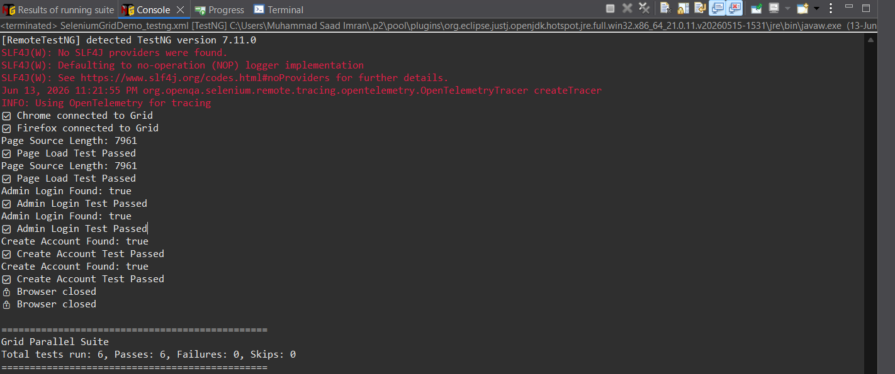
- Result Summary
All six test cases executed successfully in parallel on Chrome and Firefox browsers using Selenium Grid. The Grid Hub distributed the test execution across both browser nodes, and all assertions passed successfully. This demonstrates the successful implementation of parallel cross-browser testing using Selenium Grid and Docker.

Selenium IDE and Katalon Recorder Tests

Objective:
To implement automated GUI tests using Selenium IDE and Katalon Recorder for recording and replaying test scenarios on the e-commerce web application.

Tools Used:
Tool | Version | Purpose
Selenium IDE | 3.17.4 | Recording and exporting test scripts
Katalon Recorder | 7.1.0 | Recording and exporting test scripts
Google Chrome | Latest | Browser for test execution

Selenium IDE Test Implementation:
- Test Scenario Recorded
- Navigate to the e-commerce application
- Click on Admin Login button
- Enter email address
- Enter password
- Submit login form

- Recorded Commands
Step | Command | Target | Value
1 | open | /ecommerce_api/frontend/ | -
2 | setWindowSize | 1346x696 | -
3 | click | linkText=Admin Login | -
4 | click | id=email | -
5 | pause | 500 | -
6 | sendKeys | id=email | saad@gmail.com

- Execution Result - FAILED
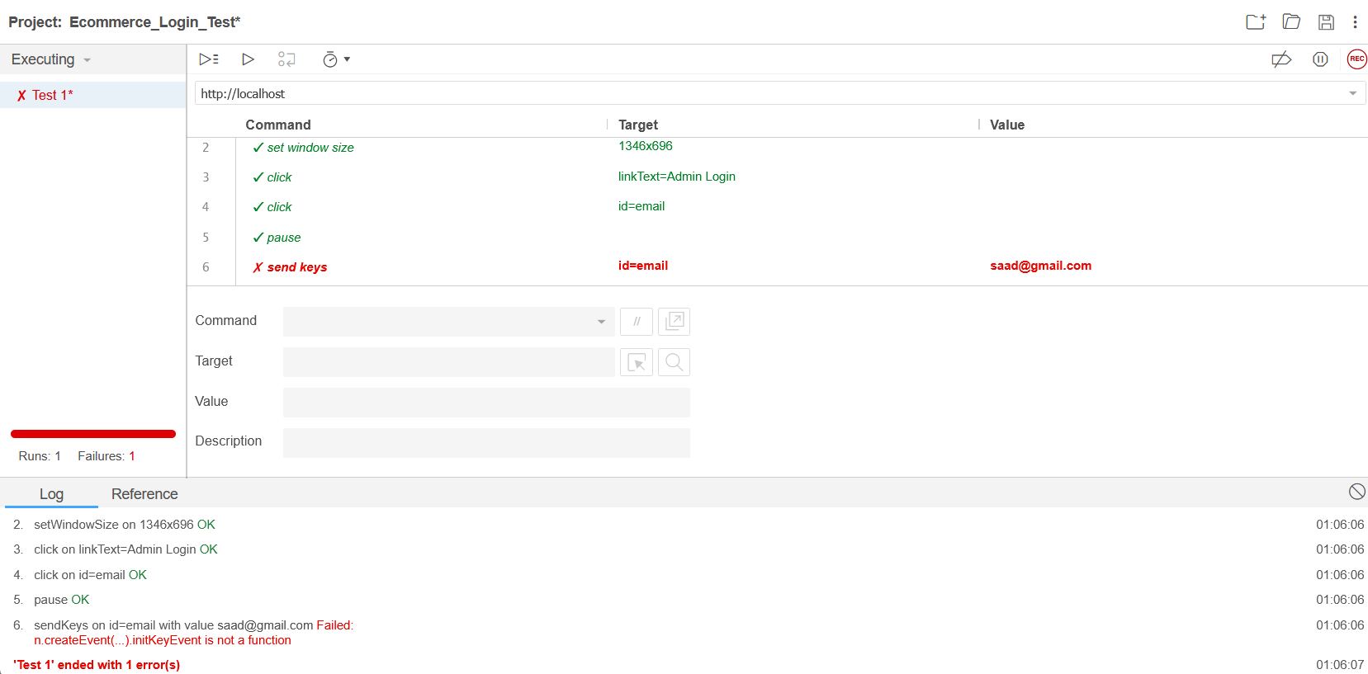

- Error Observed
sendKeys on id=email with value saad@gmail.com Failed:
n.createEvent(...) initKeyEvent is not a function
Details | Information
Tests Run | 1
Passed | 0
Failed | 1
Error Type | JavaScript initKeyEvent deprecation

Katalon Recorder Test Implementation:
- Test Scenario Recorded
- Open admin login page
- Enter email credentials
- Enter password
- Click submit button
- Verify dashboard loads
- Click logout button
- Return to login page

- Recorded Commands
Step | Command | Target | Value
1 | open | http://localhost/ecommerce_api/frontend/admin_login.html
2 | click | id=email
3 | type | id=email | saad@gmail.com
4 | click | id=password
5 | type | id=password | saad123
6 | click | xpath=//button[@type='submit']
7 | open | http://localhost/ecommerce_api/frontend/admin_dashboard.html
8 | click | id=logoutBtn
9 | open | http://localhost/ecommerce_api/frontend/admin_login.html

- Execution Result - PASSED
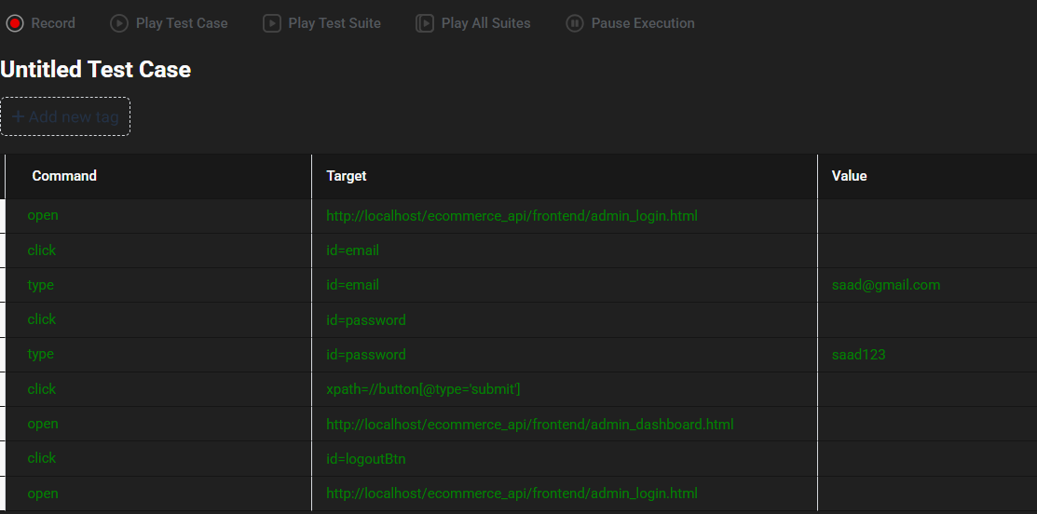
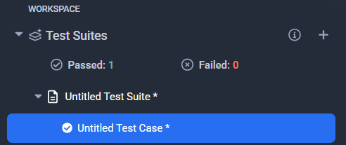

- Test Summary
Details | Information
Test Suite | Untitled Test Suite
Tests Run | 1
Passed | 1
Failed | 0
Status | All tests passed

Comparison of Results:
Criteria | Selenium IDE | Katalon Recorder
Test Execution | Failed | Passed
Error | initKeyEvent is not a function | No errors
Browser Compatibility | Poor (deprecated methods) | Excellent (modern WebDriver)
Last Update | 2021 | 2026
Recommendation | Not recommended for modern browsers | Recommended

Challenges Faced and Solutions Adopted

Technical Challenges:
No. | Challenge | Description
1 | Docker Storage Space | Docker Desktop failed to start because C: drive had insufficient space. WSL virtual disks require at least 10-15 GB free space.
2 | WSL Not Installed | Docker Desktop threw error "Windows Subsystem for Linux is not installed", preventing container execution.
3 | Docker Engine Stuck | Docker Desktop remained stuck on "Engine starting" due to WSL backend initialization issues.
4 | Selenium Grid Node Registration | Chrome and Firefox nodes failed to register with the Hub when using the --link flag.
5 | localhost Access from Docker Containers | Browser nodes inside Docker could not access http://localhost/ecommerce_api/ because localhost inside container refers to the container itself, not the host machine.
6 | TestNG Parallel Execution | Parameter 'browser' was required but not defined when running tests without testng.xml.
7 | Selenium IDE initKeyEvent Error | Selenium IDE failed with n.createEvent() initKeyEvent is not a function when trying to type in input fields due to deprecated JavaScript methods in modern Chrome.
8 | Module vs Classpath Configuration | Adding Selenium JARs to Modulepath instead of Classpath caused module descriptor errors in Eclipse.

Solutions Implemented:
No. | Challenge | Solution
1 | Docker Storage Space | Deleted old installer files (Ubuntu ISO, Android Studio, IDEA, MongoDB installers) freeing ~12 GB space.
2 | WSL Not Installed | Ran wsl --install in Administrator PowerShell to install Windows Subsystem for Linux and Ubuntu.
3 | Docker Engine Stuck | Ran wsl --shutdown followed by wsl --unregister docker-desktop and wsl --unregister docker-desktop-data, then restarted Docker Desktop.
4 | Selenium Grid Node Registration | Created custom Docker network (selenium-grid) and used SE_EVENT_BUS_HOST environment variables instead of --link.
5 | localhost Access from Docker | Changed URL from http://localhost/ecommerce_api/frontend/ to http://host.docker.internal/ecommerce_api/frontend/ to allow containers to reach host machine.
6 | TestNG Parameter Issue | Created testng.xml with browser parameters and ran tests through the XML file instead of directly running the Java class.
7 | Selenium IDE Error | Switched to Katalon Recorder 7.1.0, which uses modern WebDriver protocols and successfully executed the same test scenario.
8 | Module vs Classpath | Moved all Selenium JARs and TestNG from Modulepath to Classpath in Eclipse Build Path configuration.

Postman API Testing

Objective
To validate the backend REST APIs of the E-Commerce Admin Panel using Postman, ensuring that all CRUD operations and authentication endpoints function correctly before integration with the frontend.

APIs Tested
The following endpoints were tested using Postman:
API Endpoint | HTTP Method | Purpose
/api/auth/signup.php | POST | Register a new admin account
/api/auth/login.php | POST | Authenticate admin and receive session
/api/products.php | GET | Retrieve all products
/api/products.php?id={id} | GET | Retrieve a single product by ID
/api/products.php | POST | Create a new product
/api/products.php?id={id} | PUT | Update an existing product
/api/products.php?id={id} | DELETE | Delete a product from inventory

Test Execution
Each API request was manually executed in Postman with:
- Proper request headers (Content-Type: application/json)
- JSON request body where applicable
- Validation of response status codes and response body

Results Summary
API | Expected Status | Actual Status | Result
Sign Up | 201 Created | OK | Pass
Login | 200 OK | OK | Pass
Get All Products | 200 OK | OK | Pass
Get Product by ID | 200 OK | OK | Pass
Create Product | 201 Created | OK | Pass
Update Product | 200 OK | OK | Pass
Delete Product | 200 OK | OK | Pass

Key Observations
- All APIs returned appropriate HTTP status codes.
- Request validation worked correctly (empty fields, negative values).
- JSON response format was consistent across all endpoints.
- Authentication flow functioned properly before CRUD operations.

What We Learned
Before This Project | After This Project
Limited knowledge of REST API testing | Learned to test APIs using Postman
Did not understand HTTP methods (GET, POST, PUT, DELETE) | Successfully tested all CRUD operations
Unfamiliar with JSON request/response formats | Gained hands-on experience with JSON payloads
Did not know about status codes | Learned to validate 200, 201, 400, 404 responses

Screen Shots

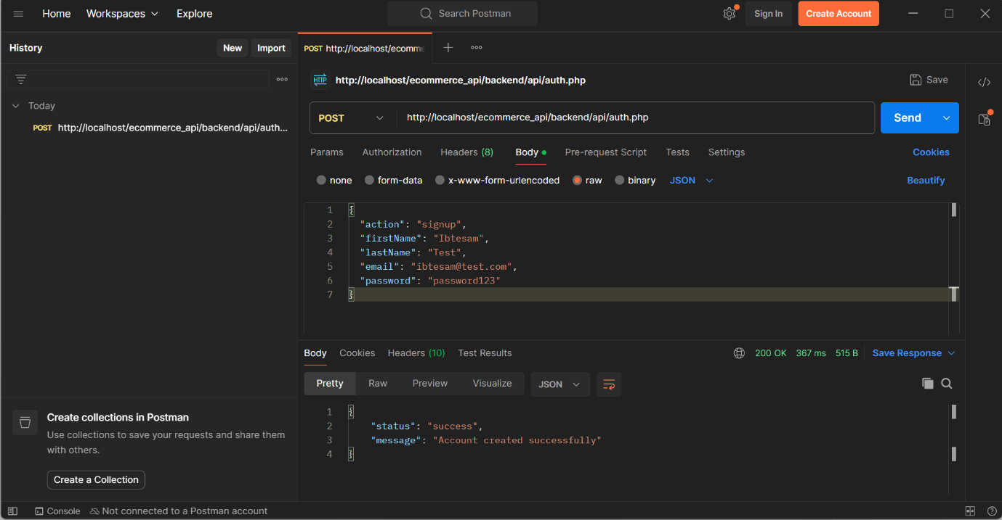
Figure 9: Sign Up

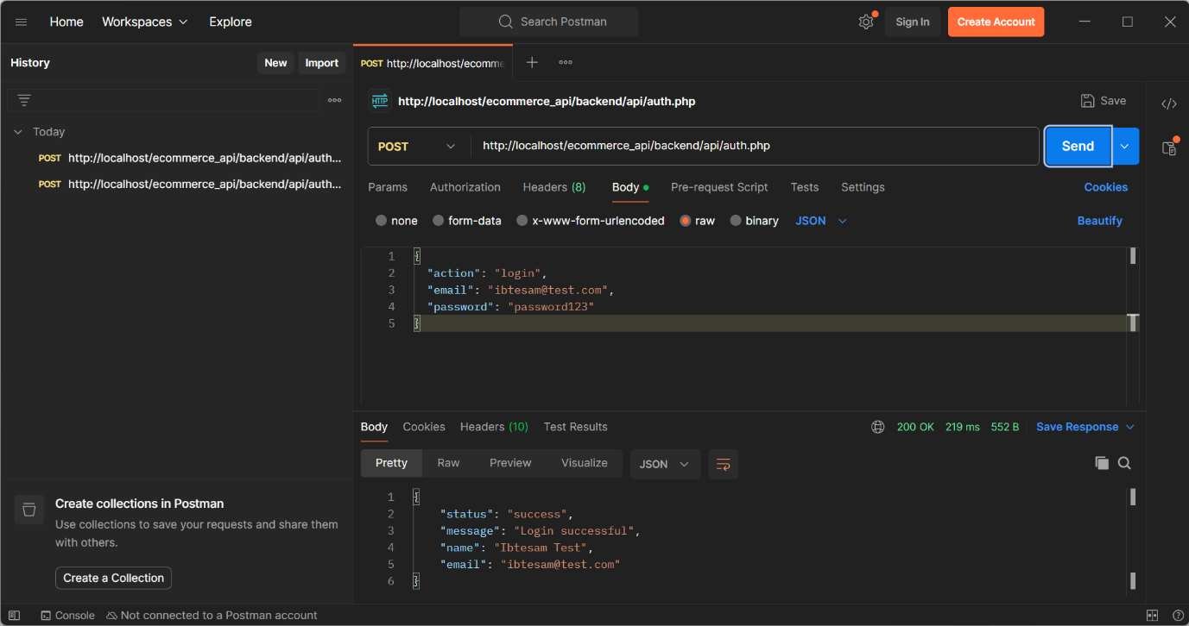
Figure 10: Login

- CRUD APIs

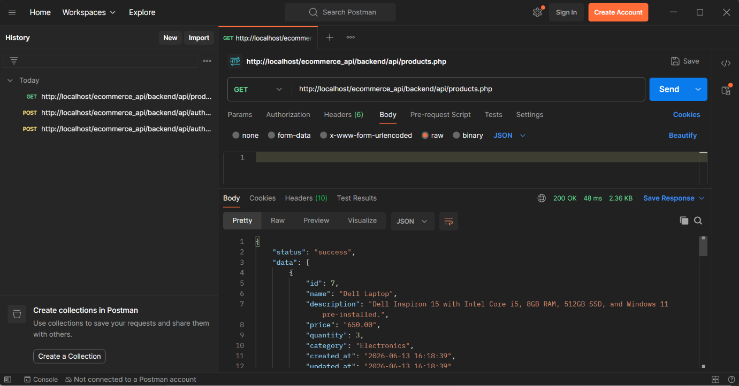
Figure 11: Get All Products (1)
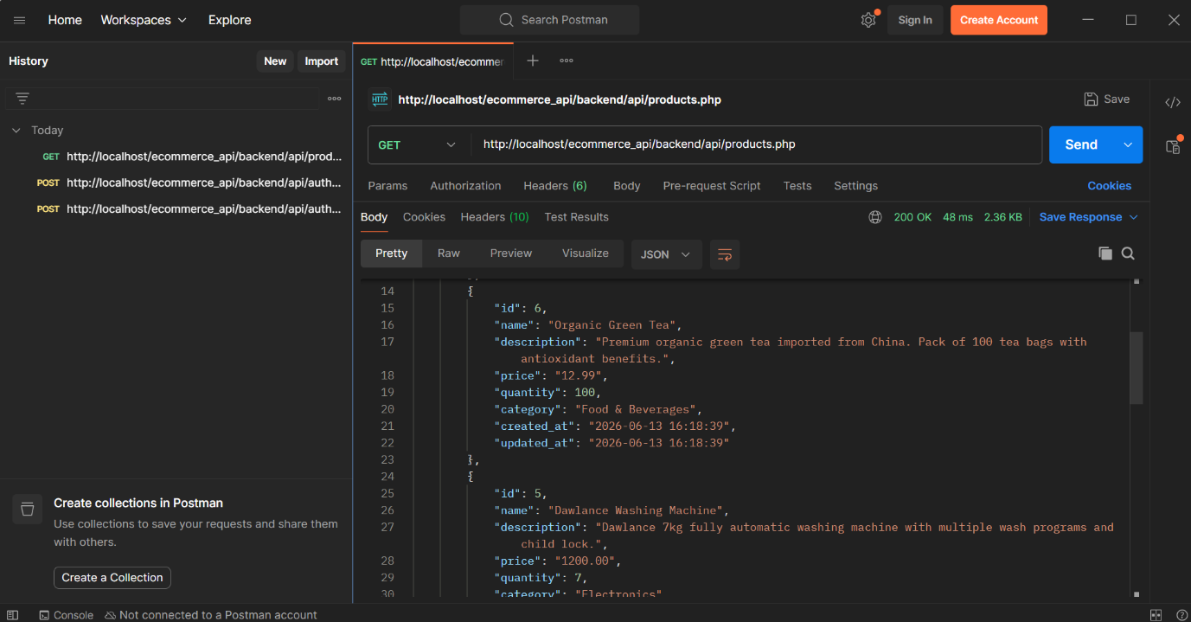
Figure 12: Get All Products (2)

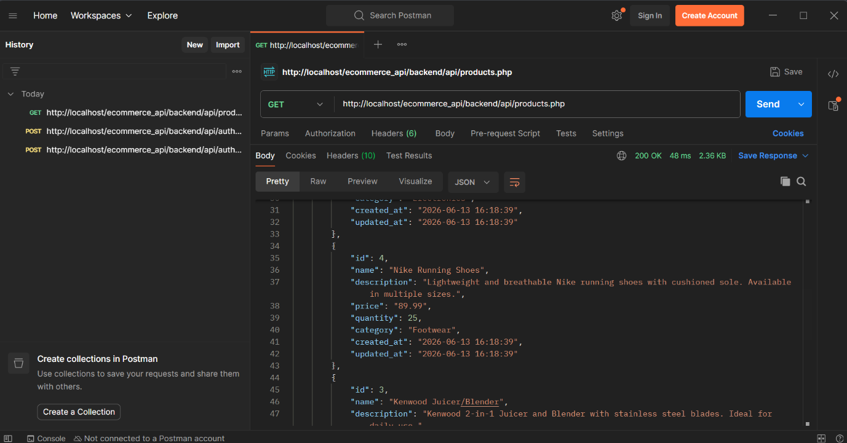
Figure 13:Get All Products (3)
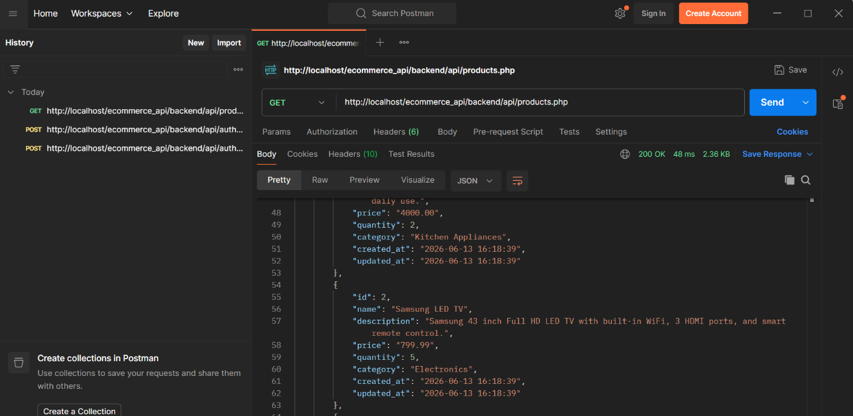
Figure 14: Get All Products (4)

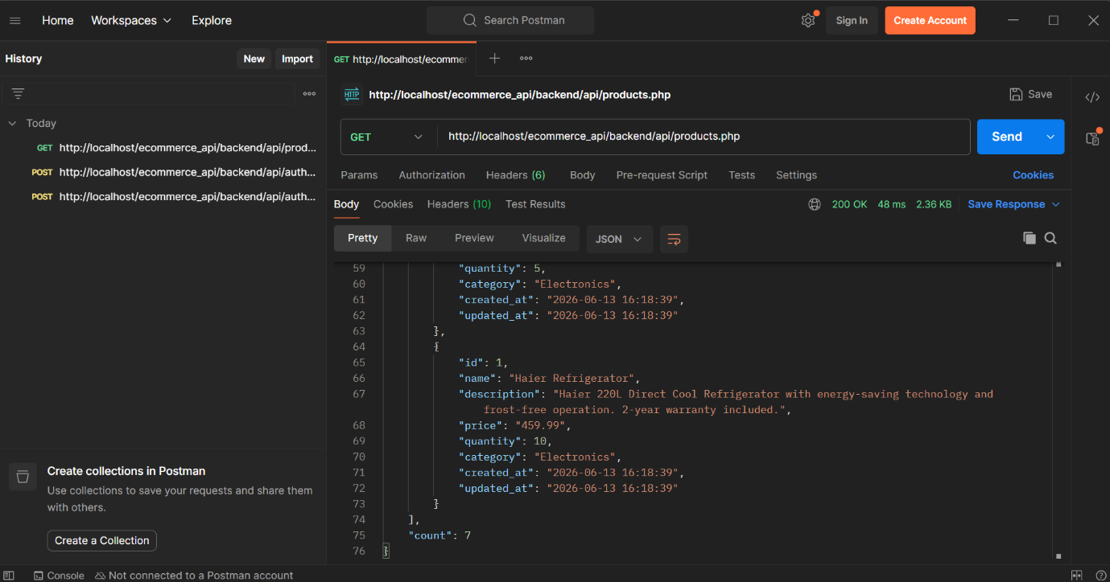
Figure 15: Get All Products (5)

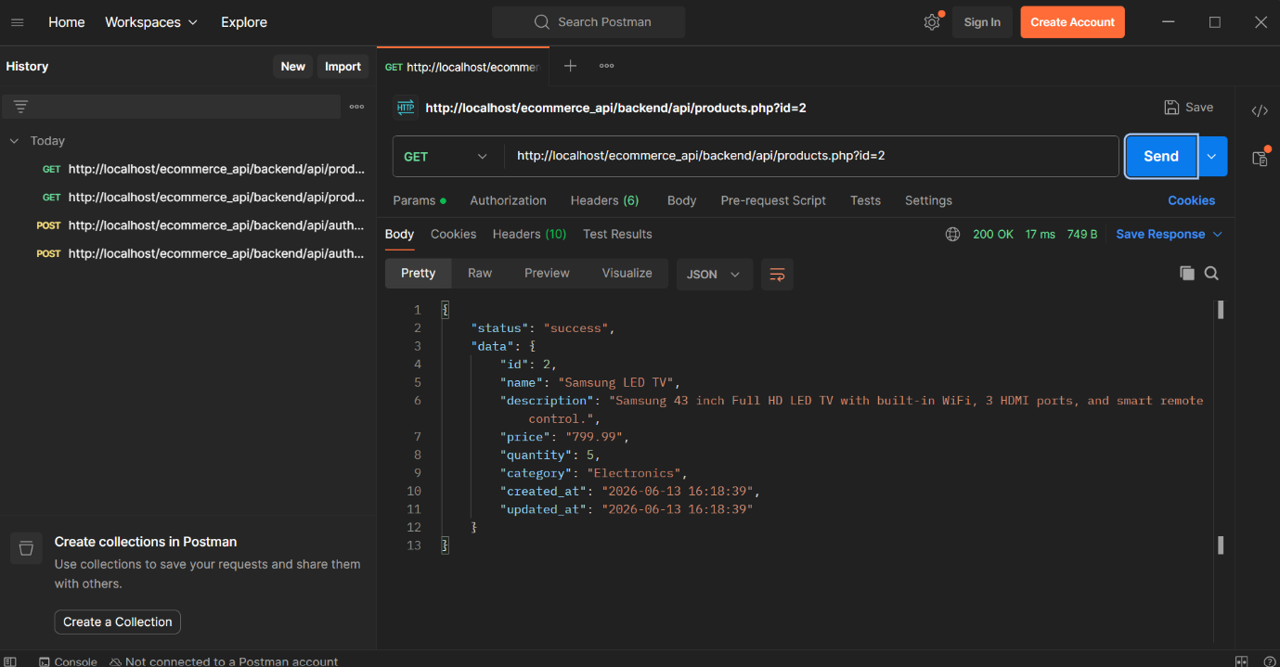
Figure 16: Get Product by id

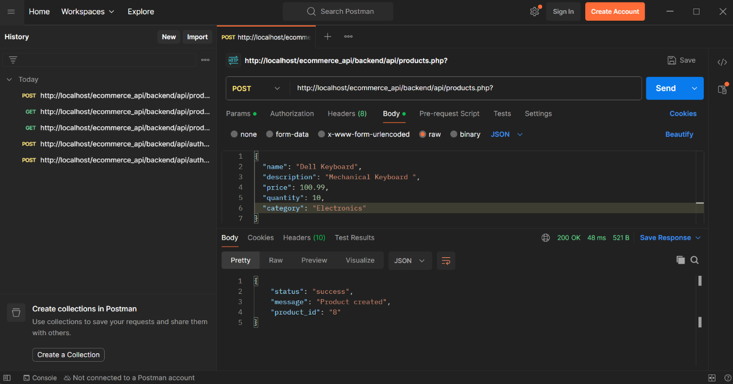
Figure 17: Create a Product

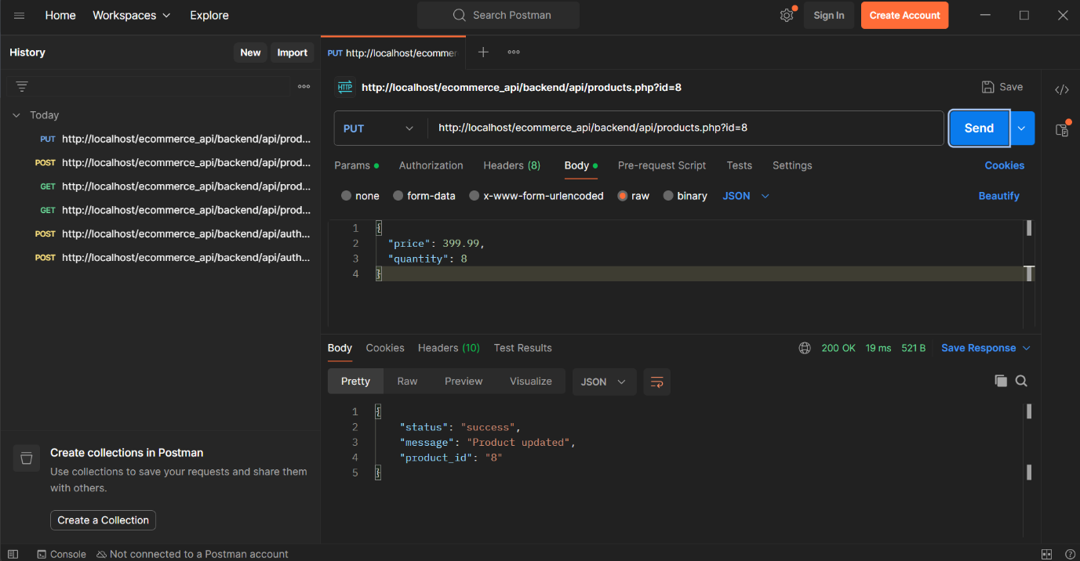
Figure 18: Update a Product (1)

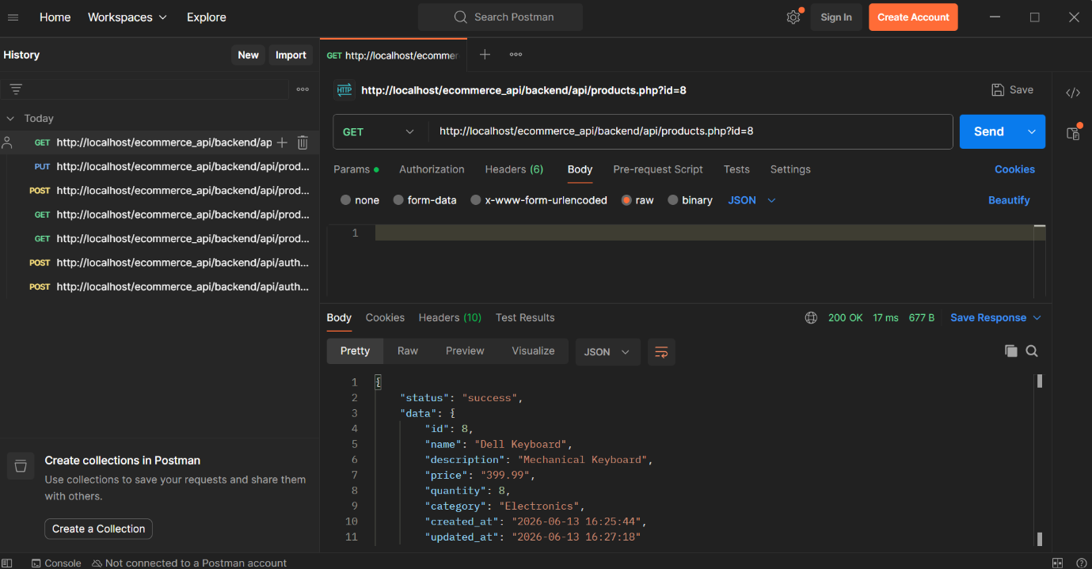
Figure 19: Update a Product (2)

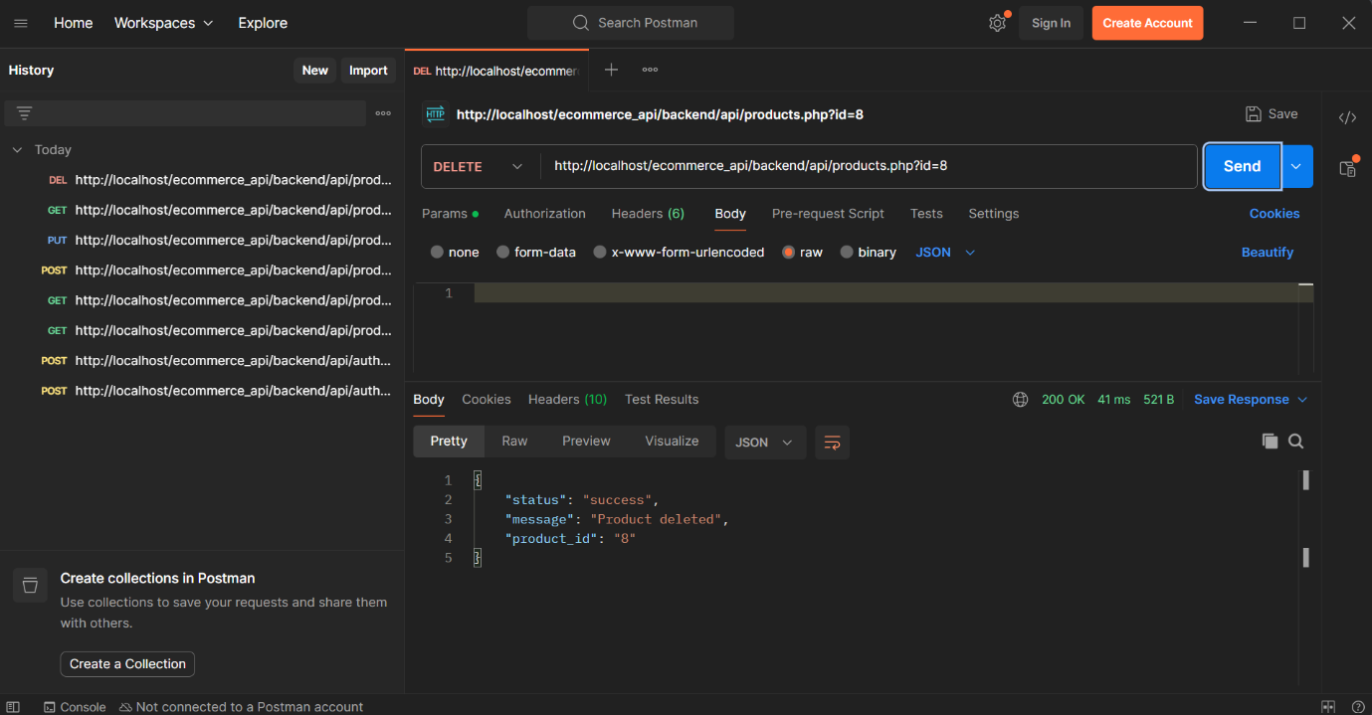
Figure 20: Delete a Product (1)

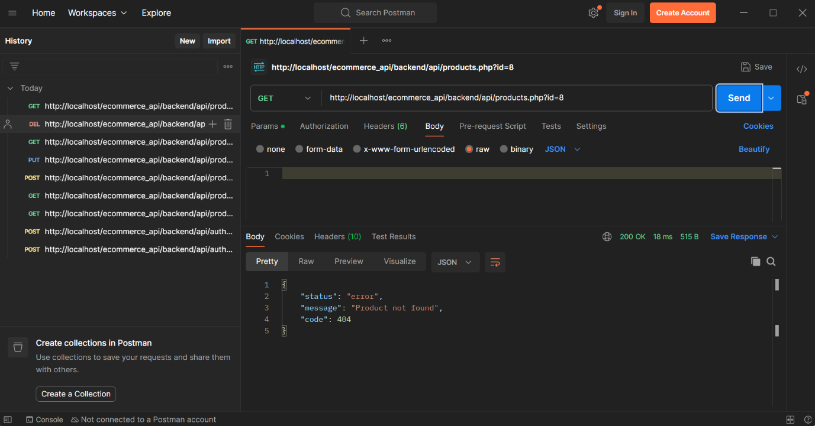
Figure 21: Delete a Product (2)

